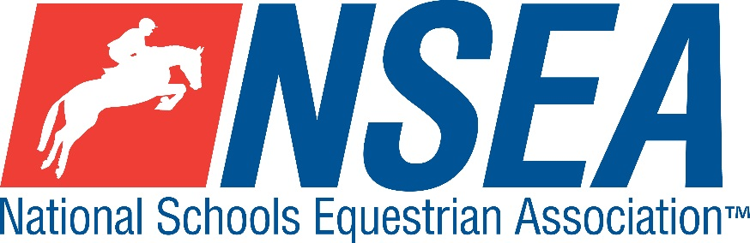

National Schools   
NSEA Show Jumping Qualifier

Kelsall Hill Equestrian Centre

Organsdale Farm, Middlewich Road, Tarporley, Kelsall, CW6 0SR

01829 708241 | [admin@kelsallhill.co.uk](mailto:admin@kelsallhill.co.uk)   
Tuesday 18th February 2025

1st & 2nd placed team & 1-4th placed individuals will qualify for the   
NSEA National Schools Championships 2025

Entries to: <https://kelsallhill.co.uk/>

Entries Close: 48 hours prior to the competition, Sunday 18th February 2024. Should we reach full capacity before this date, the entries will be closed earlier.

Class 1 Mini 70-75cm Team & Individual Qualifier   
Single phase. All team riders automatically count as individuals.

Class 2 Novice 80-85cm Team & Individual Qualifier

Single phase. All team riders automatically count as individuals.

Class 3 Intermediate 90-95cm Team & Individual Qualifier including the Windsor Qualifier

Single phase. All team riders automatically count as individuals

Class 4 1m-1.05 Open Team & Individual Qualifier including the Hickstead Elite Qualifier  
Single phase. All team riders automatically count as individuals

Class 5 1.10m Advanced Open Individual Qualifier including the Hickstead Elite Qualifier

Single phase.

Entry Fee is £24 per entry, the entry fee includes the medical fee.

**NSEA Rules – For the comprehensive Grass Roots Rules go to NSEA General Rules 2024-25 on the NSEA website. See below for eligibility in the height classes:**

**The purpose of the Grass Roots programme is to provide very novice riders with the opportunity to experience the excitement of competition. The rules are, therefore, kept as flexible as possible but, please embrace the “spirit” of the rules. Please do not use Grass Roots competitions as an easy opportunity to “pot hunt,” as it is not in the spirit of the competition.**

**The top 6 teams & individuals at qualifiers will be eligible to compete at any Regional Grass Roots Championships.**

**Start Times** will be available on the NSEA website 2 days before the competition [www.nsea.org.uk](http://www.nsea.org.uk)

**Kelsall Hill Disclaimer**

You are responsible for the health and safety of yourself and any other members of your group, whether mounted or dismounted whilst they are on site. Every person using the facilities agrees that they do so at their own risk and voluntarily accepts the risk of injury or damage that is implicit in riding or being around a horse on the premises.

Kelsall Hill Equestrian Centre does not accept any responsibility or liability for any injury, accident, damage or illness to any person, property, vehicle or animal whatsoever, or for any loss whatsoever, arising out of, or occurring at any hire, competition, show or event. It shall be a condition of entry of the facilities that each entrant shall indemnify the organisers against any legal action whatsoever arising from any accident.

Equine Influenza Vaccinations: Primary vaccinations with an in-date 12-month booster. Spot checks will be carried out. Kelsall Hill Equestrian Centre can only offer its facilities for hire on the understanding that these measures are adhered to.

**Your Responsibility***All persons attending the event must take all reasonable precautions to avoid and prevent accidents and must obey instructions given by the Organiser or by officials and stewards on its behalf.*

*All competitors and those associated with their school are the responsibility of the Team Manager whilst at the competition*

The NSEA will not be held responsible for any financial loss incurred by the attendee as a result of a cancellation.

**Child Protection & Safeguarding**  
If you have any concerns, please contact the NSEA on tel 07552 836032 / [competition@nsea.co.uk](mailto:competition@nsea.org.uk) to be put in contact with our designated Child Protection Officer. If you have immediate concerns, you can contact   
Childline tel 0800 1111 or NSPCC tel 0808 800 5000

**TV & Photography***Please note that professional photographers will be present at the Qualifiers and there may also be TV cameras at the Championships. Please indicate on the entry form if you do not wish to appear in press coverage/ TV or photos taken by our official photographers*.